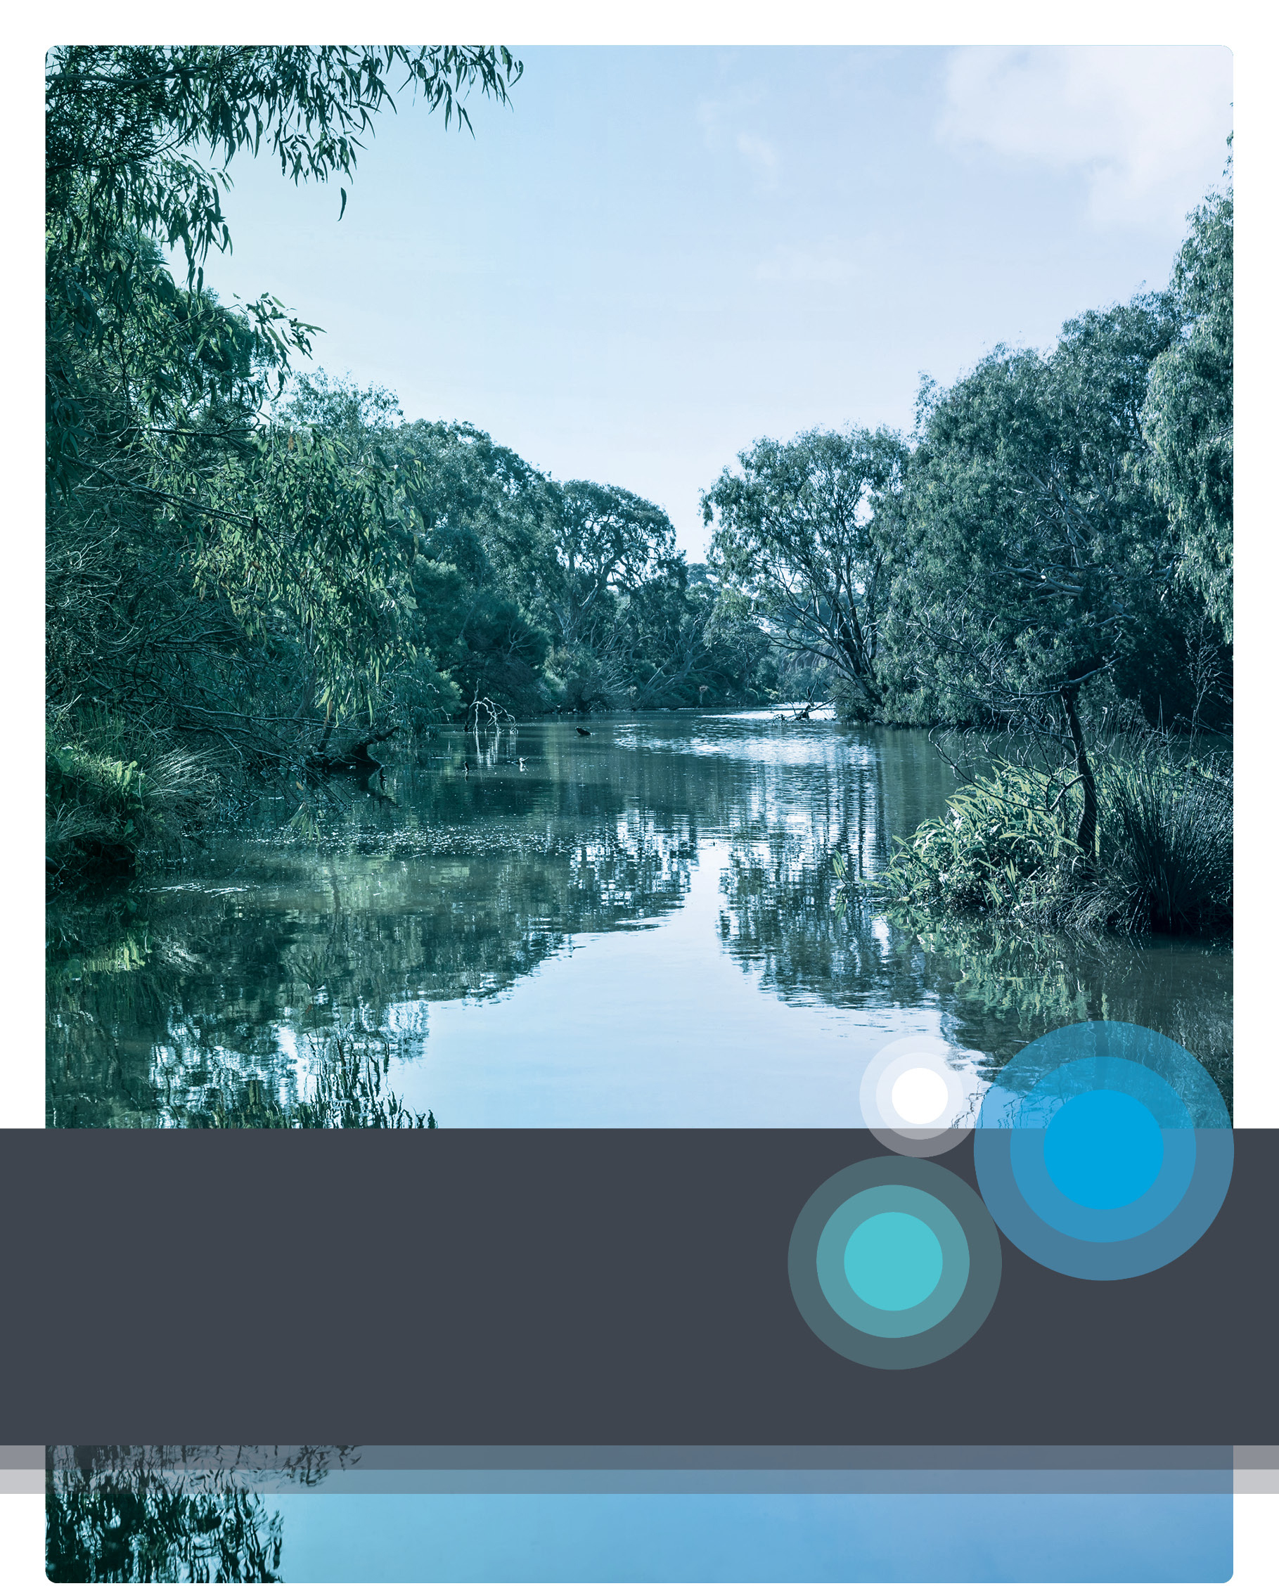
Waterways & Catchment Operations
Compliance & Enforcement Statement
Surface Water Diversions – June 2021
Acknowledgement
Melbourne Water respectfully acknowledges Aboriginal and Torres Strait Islander peoples as the Traditional Owners and custodians of the land and water on which all Australians rely. We pay our respects to Bunurong, Boon Wurrung,
Wurundjeri Woi wurrung and Wadawurrung, their Elders past, present and future as Traditional Owners and the custodians of the land and water on which we rely and operate.
We acknowledge and respect the continued cultural, social and spiritual connections of all Aboriginal Victorians. We also acknowledge the broader Aboriginal and
Torres Strait Islander community and their connections with lands and waters, and recognise and value their inherent responsibility to care for and protect them for thousands of generations.
Melbourne Water acknowledges Aboriginal Victorians as Traditional Owners and
in the spirit of reconciliation. We remain committed to working in partnership with Traditional Owners to ensure meaningful ongoing contribution to the future of land and water management.
Use of Material
This Compliance and Enforcement Statement draws upon wording and material from documents issued by
the Department of Environment, Land, Water and Planning. We gratefully acknowledge the use of this material.
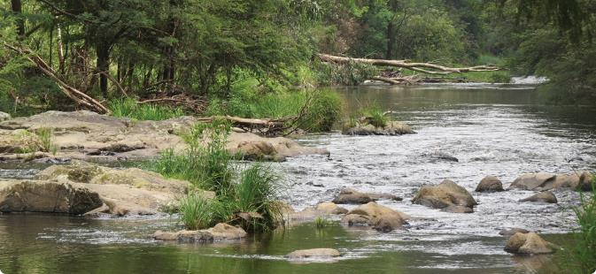

Table of Contents
1. Introduction 2
2. Purpose 2
3. Context 3
3.1 Healthy Waterways Strategy Alignment 3
4. About Melbourne Water 4
4.1 Our Vision 4
4.2 Diversions Management 4
5. Compliance and Enforcement Approach 5
5.1 Principle 1 – Risk Based 6
5.2 Principle 2 – Responsive 6
5.3 Principle 3 – Transparent 7
5.4 Principle 4 – Accountable 7
5.5 Principle 5 – Consistent 8
6. Implementation 9
7. Glossary 10
8. Document History 11
8.1 Current Document 11
8.2 Document History 11
Appendix A – Prohibited Activity and Penalties 12

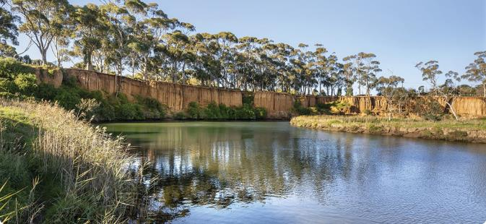

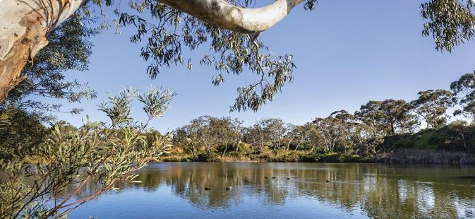

Introduction
Water is a precious but limited resource. Communities, industries, the economy, our land and waterways depend on water to support a healthy environment and for Melbourne Water’s region to grow and prosper. The Department of Environment, Land, Water and Planning (DELWP), water corporations such as Melbourne Water and the community have clear responsibilities to work together to protect our precious water resources.
Demand for water will continue to increase with population growth and climate change. Climate variability also brings greater uncertainty about the supply of water. It is crucial for water to be managed fairly for all users as we shift to a future with less inflows and available water.
A strong and clear approach to compliance and enforcement is vital to support community confidence that the same rules apply to everyone under Victoria’s water management. It is essential to deter people from illegally taking and using water and harming the environment and other water users.
This Statement specifically relates to the non-urban water, or rural sector within Melbourne Water’s area of operation. Our compliance and enforcement approach aims to maintain fair access to water resources and to impose penalties for illegal take and use of water. Our practice will be risk-based, responsive, accountable, transparent and consistent for effective compliance and enforcement and demonstrates alignment with guidance set by the DELWP.

Purpose
This Statement outlines our approach to compliance and enforcement at Melbourne Water and is intended to provide transparency to:
  - our customers who may be impacted by our enforcement or compliance activities, and
  - to Melbourne Water employees, who administer the legislation and carry out compliance and enforcement activities.
It demonstrates how Melbourne Water will meet its obligations to effectively manage and prioritise compliance risks and enforce the Victorian Water Act 1989 (the Act) as it relates to the following non-urban water services:
- Taking and using water;
- Construction, operation, maintenance, alteration and decommissioning of works; and
- Connection to the works of a water corporation.
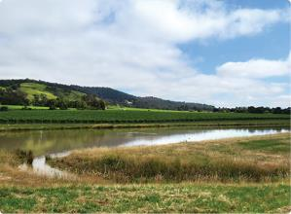
Irrigation dam in Yarra Valley
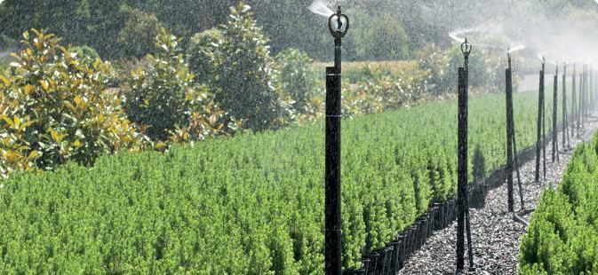

Context

The importance of having effective compliance and enforcement systems not only in Victoria, but also across Murray-Darling Basin (Basin) states and territories, was made obvious in 2017 with allegations of significant water theft and poor regulation in the northern part of the Basin. All Basin states and the Australian Government responded by agreeing to a Basin Compliance Compact in June 2018 to improve transparency and accountability of water management systems and put more consistent compliance and enforcement practices in place.
Victoria strives to maintain high standards in water compliance to be more effective in the face of changes in climate, reduced water availability and increased demand for water. The Victorian Government’s water plan, Water for Victoria (DELWP, 2016) outlines its commitment to modernising its compliance system. In Victoria, governance of compliance and enforcement in the non-urban water sector is led by the Minister for Water.
Under the Act, the Minister for Water:
- is responsible for the development of water policy and governance of the water sector.
- is responsible for issuing water entitlements and managing Victoria’s water resources for both urban and non-urban areas.
- has delegated power and functions for licence administration to water corporations such as
Melbourne Water.
- is empowered to issue authorisations relating to take and use of water and construction of works, including, but not limited to, works on waterways for the take and use of water under specific sections of the Act.
Melbourne Water is one of the six Victorian water corporations with delegated authority to provide non-urban water services under the Act. This includes responsibilities for compliance and enforcement of licence conditions and legislative requirements surrounding the take and use of water and construction of works associated with the take and use of water.
There is an expectation that all water corporations which provide non-urban water services have strategies and protocols in place to provide strong, clear systems for compliance and enforcement in water use consistent with DELWP’s ‘Non-Urban Water Compliance and Enforcement Guidelines for Water Corporations 2019’.

Healthy Waterways Strategy Alignment
Melbourne Water’s Healthy Waterways Strategy (2018) provides the strategic direction with regards to our compliance and enforcement approach. This Strategy coupled with our Stream Flow Management Plans provides guidance for the management of licences in unregulated systems and helps to identify compliance priorities. The Strategy recognises our commitment to encouraging and supporting good land and waterway stewardship, building relationships and advocating for improved outcomes, which are effective mechanisms to achieve fair and equitable sharing of water.
This Statement supports the objectives of the Healthy Waterways Strategy (2018) and seeks to further expand upon our compliance commitment. Further information on the Healthy Waterways Strategy can be found on our website: <https://www.melbournewater.com.au/healthy-waterways-strategy>

About Melbourne Water
As a statutory authority owned by the Victorian Government, Melbourne Water works on behalf of the community to deliver a range of valuable services across the greater Melbourne region.
To help make Melbourne a fantastic place to live, we supply affordable, high-quality water, provide reliable sewerage treatment and resource recovery, manage healthy waterways, provide integrated drainage management and flood resiliency, and maintain outstanding natural community spaces.

Our Vision
Melbourne Water’s vision is to enhance life and liveability across greater Melbourne. We know that water is central to life, it sustains the natural environment we live in, the communities we value, and the economy we depend on.
We deliver on our vision through our three core pillars:
- Healthy people – Providing safe, affordable, world – class drinking water and sewage treatment and supporting Melburnians to live healthy lifestyles.
- Healthy places – Managing the impacts of climate change, building resilience to flooding across the Greater Melbourne region and partnering to deliver sustainable land and water management.
- Healthy environment – Being innovative with resource recovery, reducing our emissions, improving the quality of waterways and engaging with the community on biodiversity and how to protect our natural assets.

Diversions Management
Melbourne Water manages approximately 1,800 licences to take and use water from farm dams and waterways in the Yarra catchment, lower Maribyrnong River and minor western tributaries of Stony, Kororoit, Laverton and Skeleton Creeks. Water is mainly used for agricultural, industrial, commercial, domestic and stock purposes. We also manage stormwater harvesting licences for the whole of the Port Phillip and Western Port catchments associated with Melbourne Water drainage assets. We manage licensed surface water diversions in accordance with the Act, State Government policy and state-wide diversions management practices, on behalf of the Minister for Water.
The effective management of the licensing function
is essential to ensure the health of our waterways is protected while promoting the beneficial use of these water resources within sustainable limits.
Stream Flow Management Plans, Local Management Rules, Drought Response Plan and the Diversion’s Customer Charter have been developed by Melbourne Water in consultation with customers and other stakeholders. These plans and rules define the amount of water available within a catchment, the conditions under which it can be taken and the level of service that will be achieved. Our compliance and enforcement approach is centred around adherence to these plans.
A map of Melbourne Water’s diversion catchments and related management plans is shown in Figure 1 below.

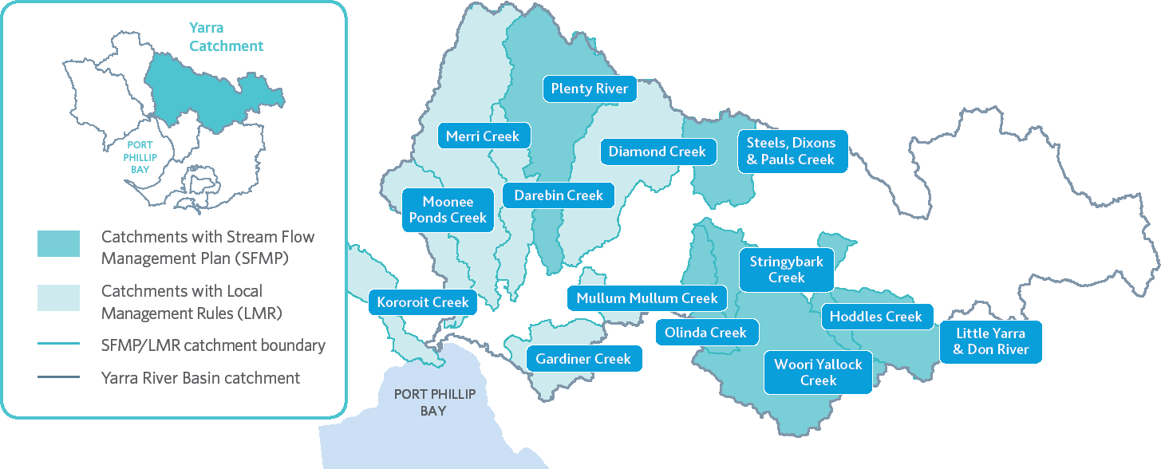
Figure 1. Catchments with Stream Flow Management Plans and Local Management Rules

Compliance and Enforcement Approach
Compliance and enforcement are two separate concepts that work together to maintain the integrity and public confidence in our management of licensed water.
- Compliance is a proactive regulatory activity where actions are taken to prevent breaches or offences (e.g. water theft) from occurring in the first instance. There are a variety of compliance tools to support compliance with Victorian water laws, including metering and data loggers to monitor water use, inspections and reporting.
- Enforcement is a reactive regulatory activity that is triggered when breaches of the law are detected. Enforcement actions under the Act include warning notices, penalty infringement notices (PINs), licence suspension or cancellation, and prosecution.
The primary purpose of enforcement is to ensure fairness, protect and enhance the health and amenity of waterways and associated land, maintain the integrity of built assets (eg drains, retarding basins, etc), and to protect the safety of the community, by making offenders accountable, and to act as a deterrent to those involved and to others. In terms of enforcement, our approach involves both:
- Reactive enforcement – responding to complaints; and
- Proactive enforcement – auditing compliance with licences conditions.
Melbourne Water will investigate compliance and enforcement issues when it becomes aware, either directly or indirectly, concerning offences under the Act or any other relevant legislation.
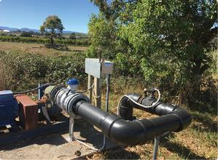
Meter and datalogger in Yarra Valley
Investigations of any alleged offence will be prioritised using a risk based approach which assists in determining enforcement priorities, having regard to the level of harm, risk of harm, likelihood of non-compliance, culpability of the offender and available resources.
Melbourne Water’s approach to compliance and enforcement is risk-based and responsive, so our actions reflect the seriousness of the offence, and built on being transparent, accountable and consistent (Figure 2 below).
Through our risk-based approach, we are committed to:
- an emphasis on education, community engagement, technology and monitoring programs to encourage and assist with compliance
- a clear and logical escalation pathway in response to detected breaches
- working in good faith with all parties and using our enforcement powers only when needed.
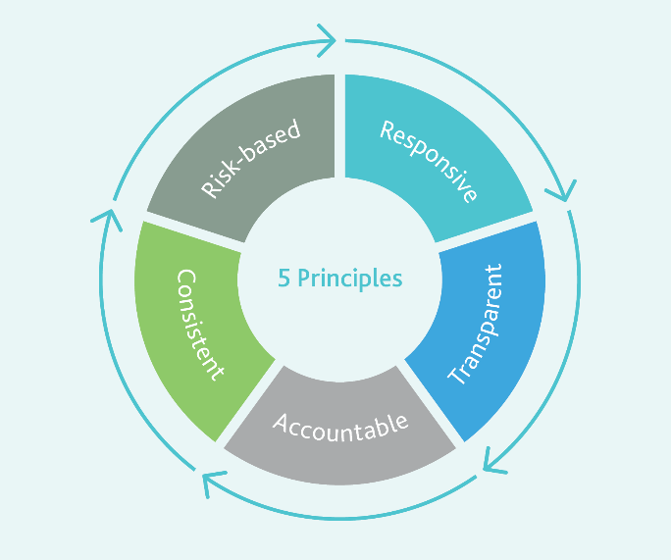
Figure 2. Five principles for an effective compliance and enforcement system
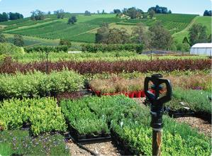
Rural Land Program nursery, Wandin

Principle 1 – Risk Based
Melbourne Water has developed its responses to the different offences under the Act based on the likelihood and consequence of harm to each water resource and the risk of a breach occurring.
Water resource risk considers the environmental profile and includes:
- the impact an unauthorised take will have on the water availability to others and the environment;
- interference with works impacting land, waterways and water quality (including environmental water requirements); and
- the social impacts such as recreational and amenity values of waterways held by the broader community.
In responding to breaches of the Act, Melbourne Water will consider the level of risk presented by the particular breach. Breaches with higher risks will be met with stricter penalties, allocation of greater resources and more rapid responses. Whilst high-risk breaches require more significant responses than lower-risk breaches, this does not mean that some level of non-compliance is acceptable.
Melbourne Water will review catchment based risk assessments at least once every four years, or when circumstances call for a review - like periods of drought, dry weather or heavy rainfalls - whichever occurs first to consider new developments and changing natural and regulatory environments. Reviews will be documented and approved by the appropriate manager.

Principle 2 – Responsive
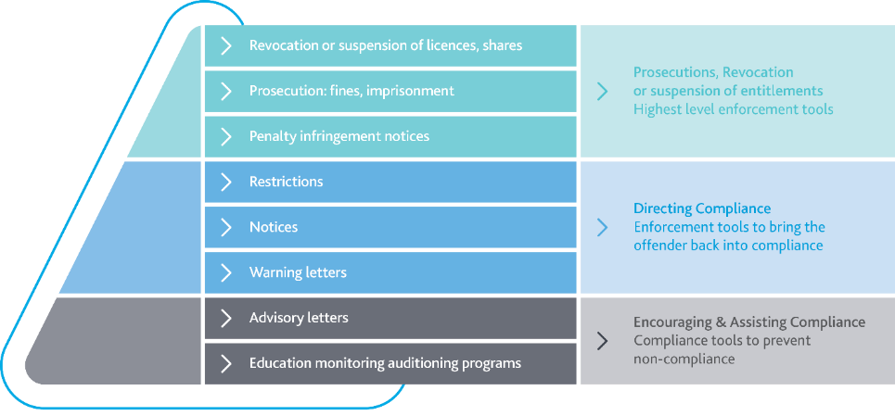
Figure 3. Compliance tools adopted by Melbourne Water (Department of Environment, Land, Water and Planning, 2019)

Melbourne Water has a range of compliance and enforcement tools available including:
- Compliance Tools: Education & information; metering; reporting and accounting;
- Detection Tools: Site visits (including powers to permit authorised officers to enter private land and request a person to state name and address), audits, monitoring data, reports and information from the general public, other agencies or regulatory authorities;
- Enforcement Tools: Various sections under the Act such as:
  - ‘Notice of contravention’;
  - Power to issue penalty infringement notices;
  - Suspension, revocation or cancellation of licence;
  - Prosecution powers.
A person who fails to comply with a notice may be subject to penalties.
These tools allow for flexible responses to different levels of risks. Melbourne Water has adopted the compliance pyramid above (Figure 3) in assessing the different options available and the escalation of responses depending on the breach.
This compliance pyramid above will guide Melbourne Water in establishing how and when the available compliance and enforcement tools can be used depending on the risk profile of the offence, water user and scale of impacts. It will inform Melbourne Water’s decision-making processes for handling detected breaches and escalation pathways for enforcement actions in response to breaches of the Act.

Principle 3 – Transparent
Melbourne Water is committed to transparency in undertaking its compliance and enforcement actions and exercising its powers and responsibilities.
Melbourne Water aims to ensure that members of the public and water users understand the general policies and procedures that it engages in to maintain fair access to water and to demonstrate that we are acting with integrity.
To facilitate this our website includes a copy of this Statement and provides information on:
- How to report on alleged water theft and other breaches of the Act;
- Our compliance and enforcement activities (e.g. annual report, newsletters). This is aimed at reassuring people that the compliance approach is effective.
Publishing enforcement decisions enables the public to see the consequences of committing an offence and may sometimes be a more effective deterrent than financial penalties; and
- How persons who have been subject to an enforcement decision can ask for enforcement decisions to be reviewed.
Further information can be found on our website <https://www.melbournewater.com.au/watertheft>
Melbourne Water is also committed to providing ongoing education and awareness programs to assist water users and members of the public in understanding and complying with their obligations and to actively engage all stakeholders in compliance activities.

Principle 4 – Accountable
The formal roles and responsibilities of Melbourne Water staff as it relates to compliance and enforcement are documented in the Instrument of Delegations issued to Melbourne Water by the Minister for Water.
Melbourne Water will ensure that compliance and enforcement functions are sufficiently independent from customer service functions to minimise potential conflicts of interest. Application of different compliance and enforcement tools will be consistent with our delegations with further detail provided below.
In addition to the roles outlined below, Melbourne Water’s General Counsel and Corporate Secretary provide oversight and legal services to enforcement matters such as prosecutions.
Melbourne Water will ensure that staff responsible for compliance and enforcement are suitably trained to carrying out their duties and that its authorised officers understand their powers and obligations under the Act.
Our Code of Conduct outlines the standard of behaviour we expect from our staff and our commitment to demonstrating the highest level of integrity.
Further information about our Code of Conduct can be found on our website <https://www.melbournewater.com.au/about/
legislation-and-policies/policies-and-procedures>

Figure 4. Melbourne Water compliance and enforcement roles
Decision makers | Compliance tools | Internal reporting
Diversions Officers, Waterways and Catchment Operations | - Education, monitoring and  auditing programs | - Annual inspection program
Diversion Program Leader, Waterways and Catchment Operations | - Education, monitoring and  auditing programs  - Advisory letters  - Warning letters  - Notices | - Team reporting within  Diversions Database  - Waterways and Catchment Operations Leadership monthly dashboard
Team Leaders, Waterways and Catchment Operations | - Education, monitoring and  auditing programs  - Advisory letters  - Warning letters  - Notices | - Team reporting within  Diversions Database  - Waterways and Catchment Operations Leadership monthly dashboard
Managers, Waterways and Catchment Operations | - Education, monitoring and  auditing programs  - Advisory letters  - Warning letters  - Notices | - Team reporting within  Diversions Database  - Waterways and Catchment Operations Leadership monthly dashboard
General Manager, Waterways  and Catchment Operations | - Restrictions  - Penalty Infringement Notices  - Revocation or suspension of licences  - Prosecution | - Annual Report  - Board reporting

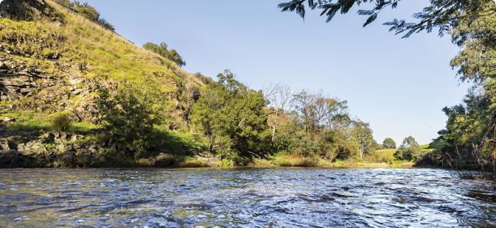

Principle 5 – Consistent

Melbourne Water’s approach to compliance and enforcement is consistent with DELWP’s policies and guidelines providing consistency across the state of Victoria. To aid consistency, Melbourne Water is an active participant in the Victorian Water Compliance Community of Practice which regularly discusses issues relating to the non-urban take of water.
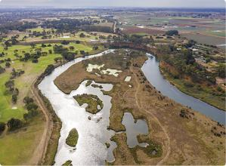
The Community of Practice enable the sharing and exchange of ideas and processes, which facilitates the development and implementation of best practice by water corporations. Membership further encourages continual and consistent growth and improvement of all water corporations.
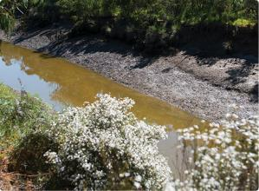
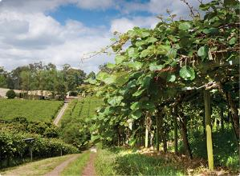

Implementation
Our efforts are focused on encouraging and assisting compliance, and we achieve this by working with our water users to ensure that they understand their obligations and take responsibility for their compliance.
This is achieved through:
    - ongoing review and development of strategic communication tools; and
    - proactive interactions with licence holders by field and diversion officers.
Through these interactions, Melbourne Water may also issue advisory letters/emails or oral advice to water users who have unintentionally breached the Act because they were not familiar with the rules and their obligations. Advisory letters or oral advices will only be sent to water users where the act of non-compliance was not deliberate; had minimal or no impact on the environment and other water users; and was a first-time offence.
To assist water users to operate in a compliant manner, Melbourne Water will continue to undertake and maintain our monitoring and auditing programs, which include annual meter reads (or bi-annual for winter-fill licences) and inspections. Implementation of our Metering Action Plan (Aug 2020) which demonstrates our commitment to improving our metering and telemetry assets to ensure our water users have accurate water usage data in a timely manner, ensures we remain at the forefront of effective water resource management.
The Metering Action Plan (Aug 2020) can be found on our website (PDF 2.6 MB) <https://www.melbournewater.com.au/media/
16656/download>.
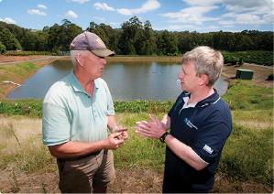
Discussion of options onsite
Melbourne Water’s focus for directing compliance will remain on educating water users on their obligations and promoting voluntary compliance, whilst ensuring potential areas of non-compliance are addressed with a clear understanding of consequences.
Stronger enforcement tools together with a clear escalation pathway for formal engagement will be utilised to bring an alleged offender back into compliance. These tools, selected depending on consideration of pre-existing knowledge, deliberateness of the action and the impact of the offence on the environment and/or other water users, include warning letters and notices.
In the most serious cases, Melbourne Water has the powers to address non-compliance through formal enforcement action. These actions target offenders who are uncooperative and often target offences that have (or have the potential, if continued) to cause unacceptable impacts on the environment and/or neighbouring water users.

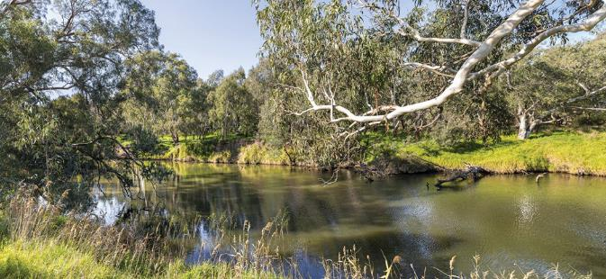

Glossary
Authorised Person:
        - any officer or employee of Melbourne Water; or
        - any person appointed in writing by Melbourne Water as an authorised officer for the purpose of carrying out particular functions of the Act.
Authorised Water Officer: any person appointed in writing by Melbourne Water as an authorised water officer for the purpose of carrying out particular functions of the Act. (section 291A(2)).
Authority: Melbourne Water as a water corporation under the Act.
Compliance: a proactive regulatory activity where actions are taken to prevent breaches or offences from occurring in the first instance. There are a variety of compliance tools to support compliance with Victorian water laws, including education, hydrographic gauging stations, metering and dataloggers, reporting and accounting.
Enforcement: a reactive regulatory activity that is triggered when breaches of the law are detected. Enforcement actions under the VWA include warning notices, reducing, restricting or discontinuing water supply or the delivery of water, issue penalty infringement notices, suspension or cancellation of an authorisation or licence, or prosecution.
Illegal Take (Unauthorised Take): the take or use of water without authorisation from the state regulatory authority (e.g. Melbourne Water). It occurs when a person takes water when they do not have a water licence, or in contravention of conditions attached to the water licence (e.g., total volume, rate or timing of take, especially if a catchment is on bans and/or restrictions) or a works licence (e.g. location, pump size or use of a compliant meter).
Notice of Contravention: a notice in writing to a person who contravenes the Act, Regulations or Authority’s by-laws including any requirements made by an Authority or licence or permit conditions as issued under the Act.
Take and Use Licence: either a fixed term or ongoing entitlement to take and use water from a waterway, catchment dam, spring, soak or aquifer (issued under section 51 of the Act).
Water Licence: a licence to take water in accordance with the Act.
Waterway: a river, creek, stream, watercourse and a natural channel where water regularly flows, whether or not the flow is continuous (as defined in section 3 of the Act).
Works: refers to a machine or construction designed to extract water, usually a pump, or a, or a dam (as defined in section 3 of the Act).
Works Licence: a licence that authorises the construction, alteration, operation, removal or decommissioning of any works on a waterway, or bore, or a dam belonging to a prescribed class of dams (issued under section 67 of the Act).

Document History

Current Document
Item | Details
Document Name | Compliance and Enforcement Statement (Surface Water Diversions)
Version Number | 1.0
Document Created | June 2021
Responsible Officer | Tim Donovan – Program Leader Diversions  Service Performance, Waterways and Catchment Operations
Reviewed by | Ross Bleazby – A/Team Leader  Service Performance, Waterways and Catchment Operations  Julie Bright – A/Manager Flood Preparedness & Service Performance  Waterways and Catchment Operations
Review Date | June 2024

Document History
Item | Details
Version Number | 1.0
Amendments | Nil.
Authorised by | Kirsten Shelly – General Manager Waterways & Catchment Operations
Action | Document Approved
Date | June 2021

Appendix A – Prohibited Activity and Penalties

Offences Relating to Take and Use of Water, Works of a Water Corporation and Breaches of Licence Conditions | Penalty
Taking or using water from a relevant water source, in a non- declared water system without authorisation under the VWA or any other Act.  Recklessly¹ or knowingly² taking, using or diverting a water corporation’s water without consent or authorisation resulting in:  (a) land, works or water being seriously damaged; or  (b) another person suffering substantial economic loss.  Section 63 | Individual, 240 penalty units; Body corporate, 1200 penalty units.  ¹Individual, 5 years imprisonment or 600 penalty units or both; Body corporate, 3000 penalty units.  ²Individual, 10 years imprisonment or 1200 penalty units or both; Body corporate, 6000 penalty units.
Taking, using or diverting a water corporation’s water without consent or authorisation under the VWA or any other Act.  Recklessly¹ or knowingly² taking, using or diverting a water corporation’s water without consent or authorisation resulting in:  (a) land, works or water being seriously damaged; or  (b) another person suffering substantial economic loss.  Section 289 | Individual, 240 penalty units; Body corporate,  1200 penalty units.  ¹Individual, 5 years imprisonment or 600 penalty units or both; Body corporate, 3000 penalty units.  ²Individual, 10 years imprisonment or 1200 penalty units or both; Body corporate, 6000 penalty units.
Interfering with the flow of water in any works under the control and management of a water corporation without consent or authorisation under the VWA or any other Act.  Recklessly¹ or knowingly² interfering with the flow of water in any works under the control and management of a water corporation without consent or authorisation under the VWA or any other Act, resulting in:  (a) land, works or water being seriously damaged; or  (b) another person suffering substantial economic loss.  Section 289B | Individual, 240 penalty units; Body corporate, 1200 penalty units.  ¹Individual, 5 years imprisonment or 600 penalty units or both; Body corporate, 3000 penalty units.  ²Individual, 10 years imprisonment or 1200 penalty units or both; Body corporate, 6000 penalty units.
Failing to comply with a notice of contravention.  Section 151 | 20 penalty units.  Melbourne Water may:  - carry out necessary works or action to remedy the contravention, and recover costs;  - remove or disconnect services and recover its costs; and  apply to court for an injunction restraining the person from contravening the notice
Appendix A – Prohibited Activity and Penalties (continued)
Offences Relating to Take and Use of Water, Works of a Water Corporation and Breaches of Licence Conditions | Penalty
Failing to comply with works licence conditions.  Section 70A | Individual, 120 penalty units  Body Corporate, 600 penalty units  Note: a licence can be suspended or cancelled by the Minster under Section 60
Offences as to obstruction of waterways etc.  Recklessly¹ or knowingly² destroying, damaging, removing, altering or in any way interfering with any property of a water corporation that results in:  (a) land, works or water being seriously damaged; or  (b) another person suffering substantial economic loss.  Section 75A | Individual, 240 penalty units; Body corporate,  1200 penalty units.  ¹Individual, 5 years imprisonment or 600 penalty units or both; Body corporate, 3000 penalty units.  ²Individual, 10 years imprisonment or 1200 penalty units or both; Body corporate, 6000 penalty units.
Failing to comply with ministerial directions  (i.e. dams etc.)  Section 78A; 80AA; 80A | Individual, 240 penalty units; Body corporate,  1200 penalty units.
Destroying, damaging, removing, altering or in any way interfering with any property of a water corporation without consent.  Recklessly¹ or knowingly² destroying, damaging, removing, altering or in any way interfering with any property of a water corporation that results in:  (a) land, works or water being seriously damaged; or  (b) another person suffering substantial economic loss.  Section 288 | Individual, 240 penalty units; Body corporate,  1200 penalty units.  ¹Individual, 5 years imprisonment or 600 penalty units or both; Body corporate, 3000 penalty units.  ²Individual, 10 years imprisonment or 1200 penalty units or both; Body corporate, 6000 penalty units.
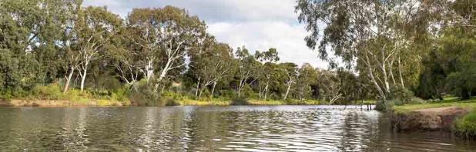

ISBN 978-1-921603-14-3 (Online)
© Copyright June 2021 Melbourne Water Corporation. All rights reserved. No part of the document may be reproduced, stored in a retrieval system, photocopied or otherwise dealt with without prior written permission of Melbourne Water Corporation.
Disclaimer: This publication may be of assistance to you but Melbourne Water and its employees do not guarantee that the publication is without flaw of any kind or is wholly appropriate for your particular purposes and therefore disclaims all liability for any error, loss or other consequence which may arise from you relying on any information in this publication.
Melbourne Water
990 La Trobe Street, Docklands, Vic 3008
PO Box 4342 Melbourne Victoria 3001
Telephone 131 722 Facsimile 03 9679 7099
Visit Melbourne Water <melbournewater.com.au)

